Hong Kong AI Customer Support SaaS
1. Idea
Build a Hong Kong-focused Software-as-a-Service (SaaS) platform that helps small and medium-sized enterprises (SMEs) use artificial intelligence (AI) customer support agents.
The AI agent would act like a first-line customer service staff member. It can answer common questions, reply in Cantonese/Traditional Chinese and English, help with booking requests, capture leads, and pass difficult cases to human staff.
Simple positioning:
A Cantonese AI receptionist for Hong Kong small businesses.

2. Problem
Many Hong Kong small businesses rely on WhatsApp, Instagram, Facebook, and website messages for customer inquiries. Staff often reply slowly because they are busy, messages come after hours, and many questions are repetitive.
This causes:
- Missed leads
- Slow replies may cause missed potential customers
- High staffing costs
- Inconsistent answers
- Too many repetitive messages
- Difficulty handling Cantonese, English, and mixed-language inquiries
- Existing bots mostly have predetermined fixed questions and fixed answers
- Mostly hand-off to a human cs employee

3. Solution
The product gives each business an AI support agent trained on its own information, such as prices, services, opening hours, policies, and frequently asked questions.
The AI can:
- Reply instantly
- Answer common questions
- Handle simple booking inquiries
- Support Cantonese, Traditional Chinese, and English
- Escalate to staff when unsure
- Reduce repetitive staff workload

4. First Target Market
We've determined the best first target is beauty and wellness businesses, such as salons, spas, nail studios, and aesthetic clinics with low-risk admin inquiries.
Why this market:
- High WhatsApp and Instagram inquiry volume
- Many repetitive questions
- Booking-driven business
- Fast replies can directly increase sales
- Owners feel staffing pressure
Other possible markets later:
- Education centers
- Online stores
- Restaurants
- Clinics
- Property agencies

5. First Product
The first version should be simple:
- Website or WhatsApp AI chatbot
- Cantonese and English replies
- Business information upload
- Human handoff
- Basic dashboard
- Basic privacy controls

6. Privacy Approach
Privacy is our core selling point. Our system does not send unnecessary personal customer data to AI providers.
- We screen the customer's input before passing onto the ai for processing
- for example, we replace the customer name Chan Tai Man with [CUSTOMER NAME]
- ensure no personal information is sent to the ai for processing
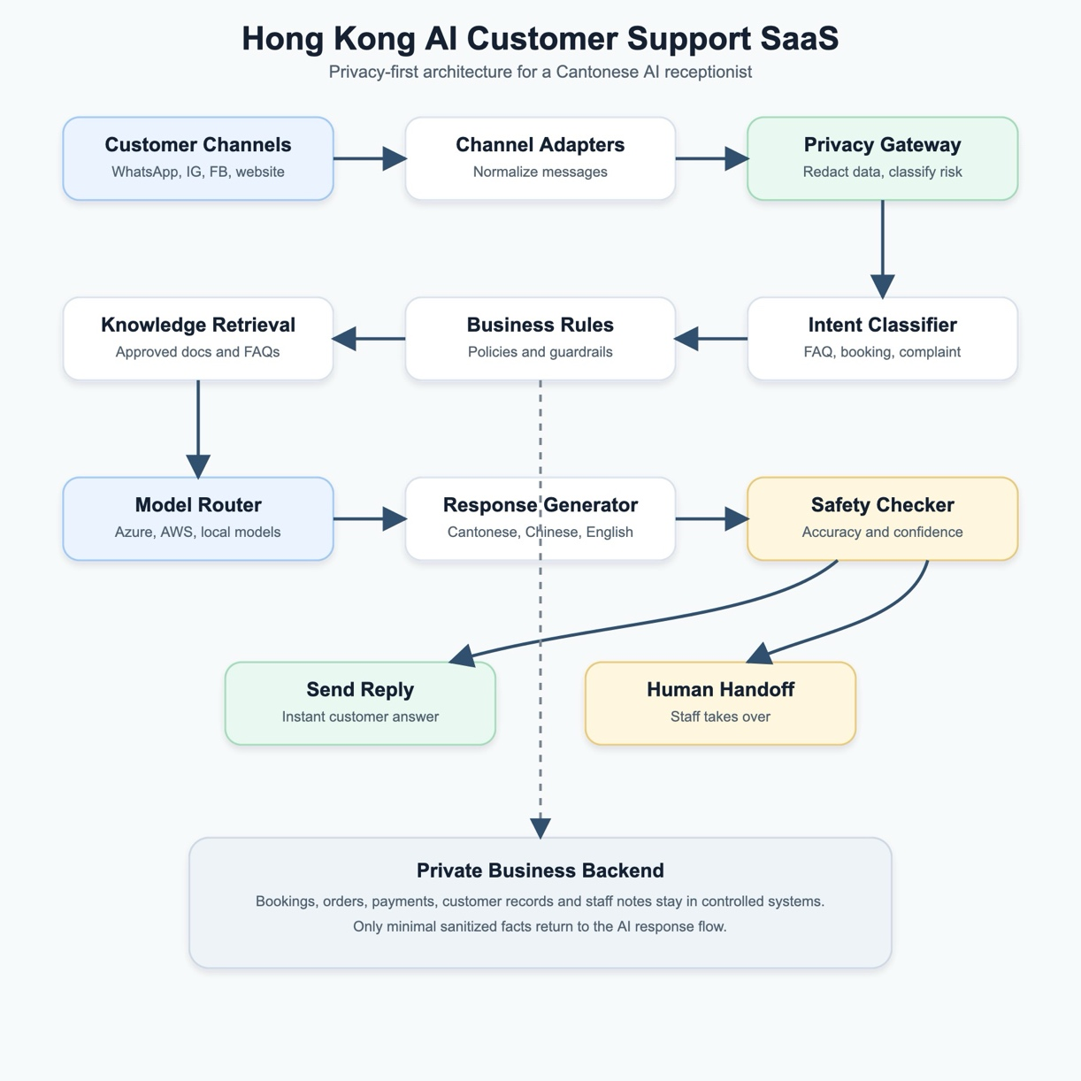

7. Business Model
Possible pricing :
- Starter: HK$688-HK$988 per month base model with no custom requirements
- Growth: HK$1,488-HK$2,988 per month
- Pro: HK$3,888+ per month
Local setup can be optional:
- No initial setup fee for local-hosting customers
- Extra monthly cost for computing for customers who need help running the agent. i.e. run in our computers

8. Go-To-Market Plan
Start with beauty and wellness businesses.
Launch approach:
- Build a demo using real salon-style inquiries
- Contact businesses through Instagram, WhatsApp, and referrals
- Offer a 14-30 day pilot
- Show how many messages the AI answered
- Convert successful pilots into monthly subscriptions

9. Main Risks
- Small businesses may not pay enough/ not willing to pay a large sum
- AI could give wrong answers
- Privacy concerns may block adoption
- Existing chatbot tools may compete aggressively, not willing to go our paid option, opting to go for free barebones models instead

The key question to validate/ before scaling this product:
Will Hong Kong small businesses pay monthly for a Cantonese AI receptionist that reduces repetitive customer messages?

